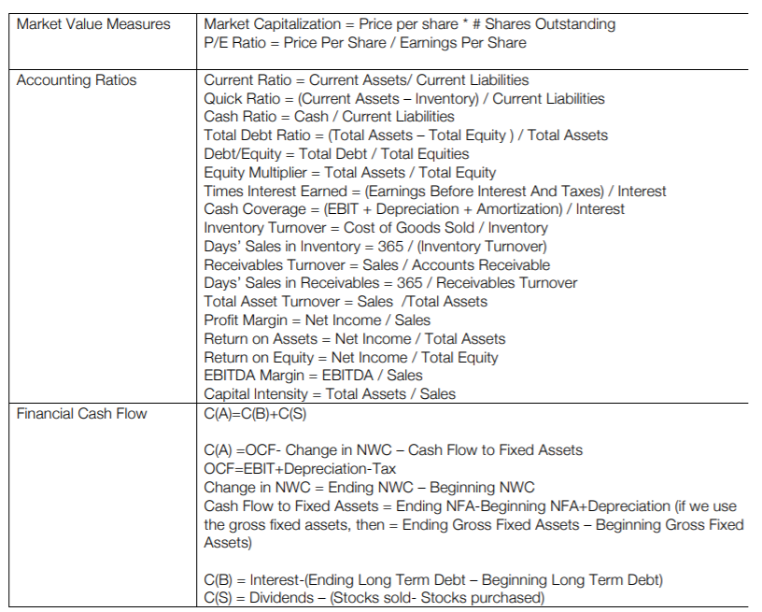

DuPont Identity = Net Income/Sales x Sales/Assets x Assets/Total Equity

Extra Review Questions:

Pros/cons of a company going public? Is there a cost to going public?

Why would you see a big goodwill account in a tech company’s balance sheet?

Why do companies still care about the stock price (after they initially go public)?

Why would a company purchase back their own stock?

From one year to the next EBIT is positive but net income is negative – what can you deduce from this?

Net income/total assets (ROA) is particularly low for a company even though profit margin is high. Should we be worried? What can we check to ease our worries?